 |  | ConsumerInsight Press Release
Research | ConsumerInsight |  | Email | kimmh@consumerinsight.kr
Contact | Minhwa Kim |  | Phone | +82-2-6004-7643
Release date | October 29, 2025 Wednesday |  | Page | Total 5 pages
Copyright © ConsumerInsight. All rights reserved. All content in this material—including documents, analyses, and charts—is copyrighted by ConsumerInsight Co., Ltd. It may be cited or reported only for the purpose of news reporting. Any other form of reproduction, distribution, posting, display, transmission, or secondary use is allowed only with prior written consent. Unauthorized use may result in legal liability under copyright law and related regulations.

Spain Overtakes Switzerland to Rank No. 1
in Travel Satisfaction Among Koreans
ConsumerInsight “2025 Summer Vacation Travel Satisfaction Study” Report ②: Overseas Travel

- Switzerland drops from 4-year top spot to 4th
- Portugal 2nd, Czech Republic 3rd; Southern and Eastern Europe rising
- Austria, France, Germany see sharp declines
- Value for money shapes Europe travel satisfaction

○ Spain has taken the No. 1 spot in overseas travel satisfaction among Korean travelers for the first time, overtaking Switzerland, which had maintained the top position for the past four years. Southern European destinations—including Portugal in second place—showed notable gains, while Central and Western European countries such as Switzerland experienced a downturn. Meanwhile, Eastern European destinations like the Czech Republic and Croatia are emerging as new favorites. In the past, rankings were influenced by “emotional value for money,” but now they are being reshuffled based on actual “value for money.”
□ Based on the Annual Travel Satisfaction Study conducted every September since 2016 by ConsumerInsight, a travel research institute, this study surveyed 13,287 travelers who took overseas trips and 17,229 consumers who traveled domestically for summer vacations (June–August) over the past year (September 2024–August 2025). Respondents were asked about their main travel destinations, their satisfaction with the destination, and their likelihood to recommend it. Overall satisfaction scores were calculated, and 32 countries with at least 60 responses were compared.

■ Europe scores 752 points, well above the global average of 725
By country, Spain ranked first with an overall satisfaction score of 808 points, the only nation to exceed the 800-point range [Figure 1]. Portugal (793 points) ranked second, followed by the Czech Republic (791 points) in third. Switzerland, which had held the top spot for four consecutive years (excluding the three years from 2020 to 2022 when the study could not be conducted due to COVID-19), fell to fourth place. Croatia, which was excluded from last year’s ranking due to an insufficient sample size (fewer than 60 respondents), entered the list this year with 781 points, placing fifth — making all of the top five countries European.

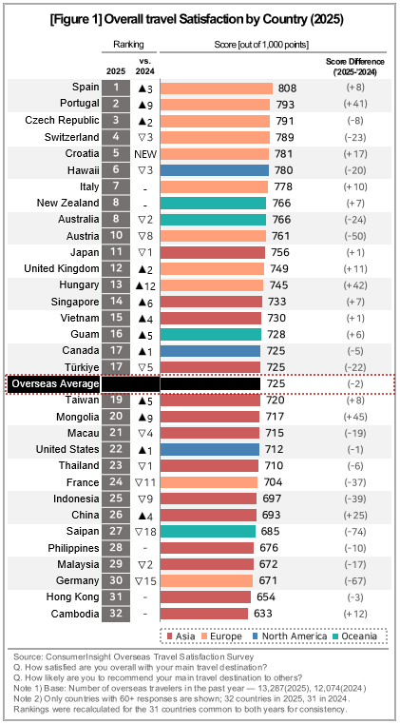
○ Following that, Hawaii (780 points), Italy (778 points), New Zealand and Australia (766 points each), and Austria (761 points) made it into the top 10. Japan, with 756 points, fell one place from the previous year to 11th but remained the highest-ranked Asian country.
It was followed by the United Kingdom (749 points), Hungary (745 points), Singapore (733 points), Vietnam (730 points), Guam (728 points), and Canada and Türkiye (725 points each). In total, 18 countries scored above the global average of 725 points.
○ Overall satisfaction with overseas travel scored an average of 725 points (out of 1,000), down two points from last year. By region, Europe ranked highest with 752 points, while Oceania, which had scored similarly to Europe last year, fell sharply by 17 points to 738. The Americas followed with 727 points, and Asia with 721 points, while Africa lagged behind other regions with 681 points.

■ High Prices Slow Western Europe, While Low-Cost Southern and Eastern Europe Surge
○ Spain claimed the top spot for the first time since this study began in 2016. Despite consistently ranking among the highest in traveler satisfaction over the past two years—placing second and fourth—it had repeatedly been overtaken by Switzerland. Neighboring Portugal rose nine places from 11th last year, and Italy maintained its seventh-place ranking, resulting in a strong showing for three Southern European countries in the top 10.
○ In Eastern Europe, the Czech Republic climbed two spots from fifth to third, while Croatia, which was excluded last year due to an insufficient sample size, entered fifth place. Hungary also made a notable leap, rising 12 places to 13th. Relatively low prices, local cuisine, and a relaxed, romantic atmosphere appear to have contributed to high traveler satisfaction in these regions.
○ By contrast, Central and Western European destinations—long regarded as popular but high-cost among Korean travelers—showed a decline. Switzerland and Austria, which ranked first and second last year, fell three and eight places respectively, while France dropped 11 places to 24th, and Germany fell 15 places to 30th.
○ Notably, even Switzerland — once considered a high-cost yet high-satisfaction destination offering strong emotional value for money — has joined the downward trend, along with traditionally high-cost, low-satisfaction destinations such as France and Germany. (Reference: “Contrasting European travel experiences – Switzerland vs. France” July 9, 2024). Considering the significant rise in rankings for low-cost, high-satisfaction Southern and Eastern European countries, it appears that travelers are increasingly evaluating destinations based on practical cost-effectiveness rather than perceived emotional value.
■ Fourteen Countries Below the Global Average, Ten in Asia
○ Among the 14 countries scoring below the global average of 725 points, 10 were in Asia, keeping most of the region in the lower ranks. Mongolia (20th) and China (26th) also remained in the lower tier but climbed nine and four places, respectively, thanks to significant increases in satisfaction scores (+45 points and +25 points). By contrast, Saipan fell 18 places to 74 points, recording the largest drop among all destinations.
■ Seven of the Top Ten Asian Travel Destinations Are in Japan
○ This survey also analyzed satisfaction for major destinations as well as for countries. Among popular Asian destinations for Korean travelers—Japan, Vietnam, Thailand, China, the Philippines, Taiwan, Malaysia, and Indonesia—Japan’s Sapporo (786 points) and Okinawa (769 points) ranked first and second (Figure 2). Apart from Vietnam’s Nha Trang (762 points, 3rd) and Phu Quoc (761 points, 4th), and Thailand’s Chiang Mai (735 points, 9th), seven of the top ten destinations were in Japan.
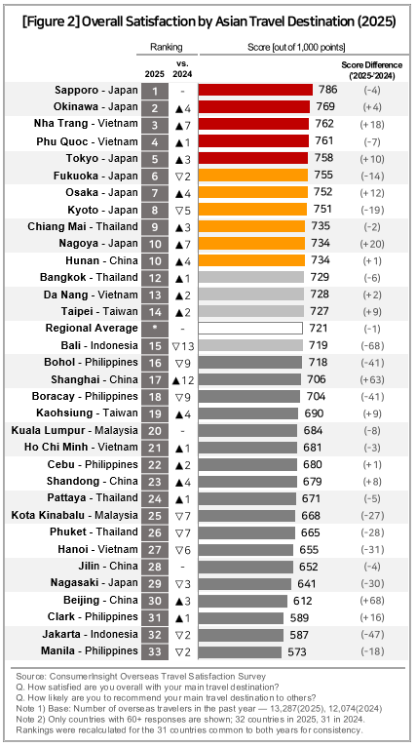
○ There were significant differences in satisfaction even within the same country. In Japan, the top-ranked Sapporo (786 points) scored 145 points higher than Nagasaki, which ranked 29th (641 points). In China, Hunan (734 points, 10th) outscored Beijing (612 points, 30th) by 122 points. Choosing the best destination within a country is important for having a more satisfying travel experience.

■ Practicality over Sentiment, Value for Money over Emotional Satisfaction
○ About 80% of Koreans’ overseas trips are still within Asia, including Japan. Long-haul trips to Europe or the Americas are often “once-in-a-lifetime dream journeys,” where psychological satisfaction takes priority over cost. However, recent trends show travelers increasingly considering practical factors such as prices, exchange rates, safety, and comfort, prioritizing practicality over sentimental experiences. Following domestic travel, overseas trips are also expected to shift toward value for money rather than emotional satisfaction, with travelers placing greater value on actual satisfaction over idealized ones.

=====================================================================
This report is based on the Annual Summer Vacation Travel Satisfaction Study, conducted every September by the ConsumerInsight Consumer Trends Research Institute, surveying more than 25,000 travelers each year. Updated survey results and analysis reports are available at https://www.consumerinsight.co.kr/leisure-travel/, where summary data from the 2017–2024 surveys can also be downloaded. (Download the report)
For-more-Information
Minhwa Kim/Ph.D | kimmh@consumerinsight.kr | 82-02-6004-7643
Jihye Lee | leejh2@consumerinsight.kr | 82-02-6004-7693

